PYTHON PROGRAMMING
CASE STUDY ASSIGNMENT - 2

1. Problem Statement
Warehouse inventory management involves tracking the quantities of different products stored in a warehouse. The opening stock, incoming quantities, and dispatched quantities must be compared with the actual closing stock to identify discrepancies. This project develops a Python program to calculate the expected closing stock for multiple products, compare it with the actual closing stock, identify shortages or surpluses, and calculate replenishment requirements.

2.Objectives
- To calculate the expected closing stock of multiple products.
- To compare expected stock with actual closing stock.
- To identify stock shortages and surpluses.
- To calculate the replenishment quantity required to reach a target stock level.
- To maintain accurate inventory records using Python.

3. Assumptions
- Each product has a unique name.
- Opening stock, incoming quantity, dispatched quantity, and actual closing stock are entered as non-negative whole numbers.
- Dispatched quantity should not exceed the available stock.
- Expected closing stock is calculated as opening stock plus incoming quantity minus dispatched quantity.
- A difference between expected and actual closing stock is treated as a discrepancy.
- The target stock level is provided by the user to calculate replenishment requirements.

4. Algorithm
- Start the program.
- Ask the user to enter the number of products.
- For each product, input its name, opening stock, incoming quantity, dispatched quantity, actual closing stock, and target stock level.
- Calculate the expected closing stock using the formula:
- Expected Closing Stock = Opening Stock + Incoming Quantity − Dispatched Quantity
- Compare the expected closing stock with the actual closing stock.
- If both values are equal, display "No Discrepancy".
- If actual closing stock is less than expected closing stock, calculate and display the shortage.
- If actual closing stock is greater than expected closing stock, calculate and display the surplus.
- Calculate the replenishment quantity required to reach the target stock level.
- Display the inventory report for each product.
- Stop the program.
5.Flowchart
Start
Input product details
Input number of products
Calculate expected closing stock

6. Pseudocode
Compare expected and actual stock

Identify shortage, surplus, or no discrepancy
Calculate replenishment quantity
Display inventory report
Stop
START
INPUT number_of_products
FOR each product
INPUT product_name
INPUT opening_stock
INPUT incoming_quantity
INPUT dispatched_quantity
INPUT actual_closing_stock
INPUT target_stock_level
expected_closing_stock =
opening_stock + incoming_quantity - dispatched_quantity
DISPLAY expected_closing_stock
IF actual_closing_stock = expected_closing_stock THEN
DISPLAY "No Discrepancy"
ELSE IF actual_closing_stock < expected_closing_stock THEN
shortage = expected_closing_stock - actual_closing_stock
DISPLAY shortage
ELSE
surplus = actual_closing_stock - expected_closing_stock
DISPLAY surplus
END IF
replenishment_quantity =
MAXIMUM(0, target_stock_level - actual_closing_stock)
DISPLAY replenishment_quantity
END FOR
STOP
7.source code
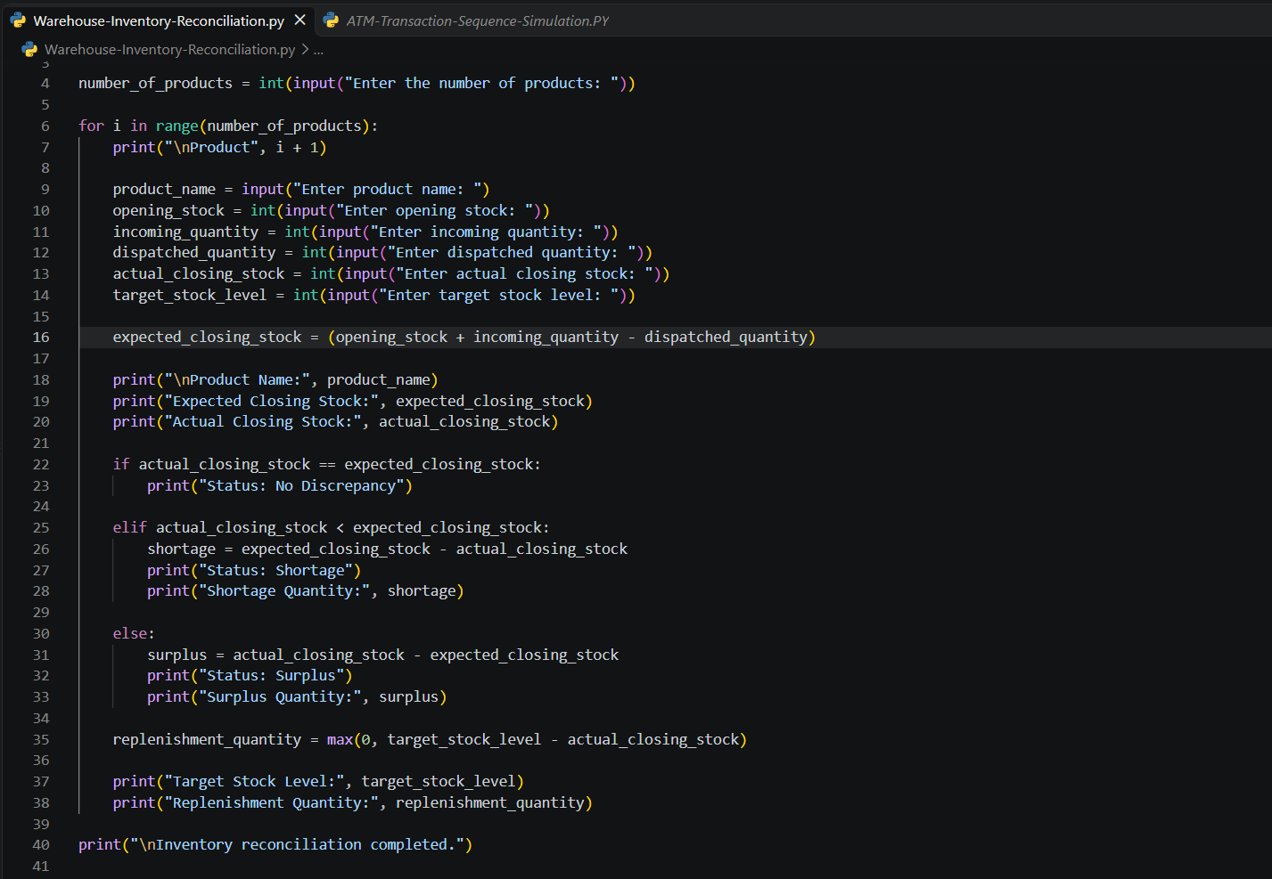

8.Test Cases

Test Case | Product | Opening | Incoming | Dispatched | Actual Closing | Target | Expected Result
TC1 | Notebooks | 100 | 40 | 30 | 110 | 150 | No discrepancy; replenishment 40
TC2 |  | 200 | 50 | 80 | 160 | 250
  Pens
  Shortage 10; replenishment 90
TC3 | Pencils | 150 | 20 | 40 | 135 | 180 | No discrepancy; replenishment 45
TC4 | Erasers | 100 | 30 | 20 | 120 | 100 | Surplus 10; replenishment 0

9. Output Screenshots
The output screenshot demonstrates the execution of the Warehouse Inventory Reconciliation Python program. It displays the product details, expected closing stock, actual closing stock, discrepancy status, and replenishment quantity.

Screenshot 1: Successful execution of the Warehouse Inventory Reconciliation program.
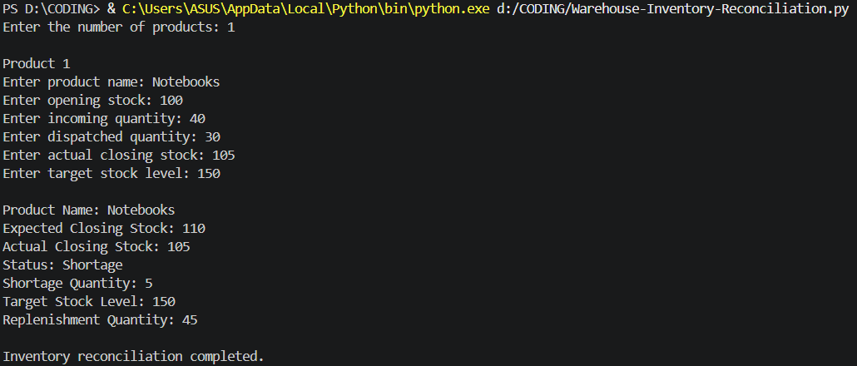
10. Conclusion
The Warehouse Inventory Reconciliation project was implemented using Python. The program calculates expected closing stock from opening stock, incoming quantities, and dispatched quantities. It compares expected stock with actual stock to identify shortages, surpluses, or no discrepancies. It also calculates the replenishment quantity required to reach the target stock level. This project demonstrates the practical use of variables, user input, arithmetic operators, conditional statements, and loops in inventory management.

